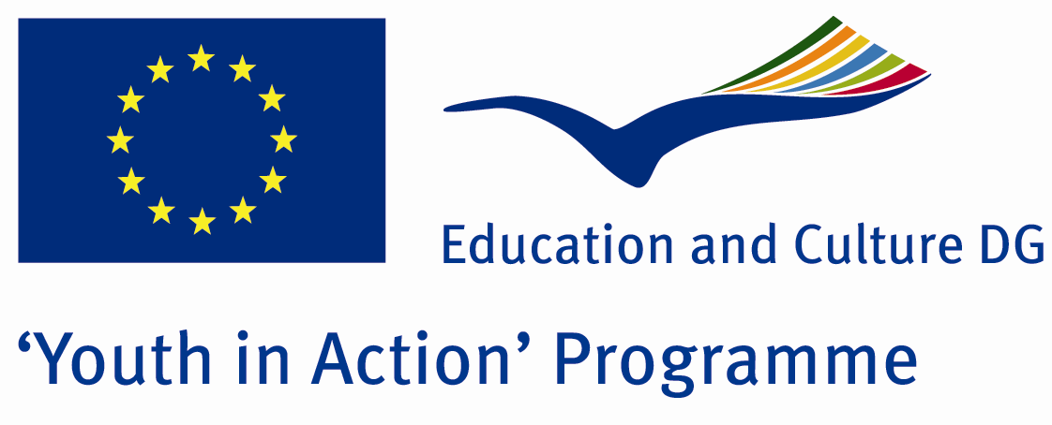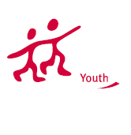

Action 1.1
Project Summary; 826 million of 6 billion living on earth suffer from hunger, and 1.3 billion are facing poverty. Over 790 million people, facing food poverty, are living in developing countries, of which 36 million are in developed countries. 1.2 million people in the world lack safe drinking water. World is running out of energy resources, due to misuse which leads to global warming. What is the solution? we seek answers to this question and try to develop solution during our project. Are you in?

Project Title; LIVE,PROTECT,LEAVE LIVABLE
Date and Venue ; 01-08 August Turkey
Place: Burdur.

Target Group ; Municipalities, City Councils and Non-Governmental organizations,
youth groups,culture and art groups,e.t.c

Participants ; 5 people from each country (over 18 -25 ). Totally 8 countries.

Conditions ; Accommodation, board and programme costs will be financed through European Commission Youth in Action Programme . Travel costs will be reimbursed in 70% (APEX Tarrifs). Organizations from all 27 EU member countries plus Liechtenstein , Norway and Iceland are eligible to take part.

Working language: English

Organisator group: Grup Kibyra

How to apply: If you are interested, please send your Part III forms to
by e-mail please (in word file). Scan Part3 format is enough for application.(Fulfilled Part III which you can find in the attachment, of course signed and stamped) ..

Contact e-mail: groupkibyra@gmail.com

